Task Questions

Question 1

Module 14 Knowledge check

This knowledge check was comprised of the most important questions throughout the module 14. The questions asked was kind of a summary to the whole module 14. In this knowledge check I was able to see my understanding of this module, and the from the mistakes I was able to correct myself of the parts that I was not sure about.

This knowledge check was mostly about Disaster recovery plan. The first question itself was about Recovery Point Objective (RPO) and Recovery Time objective (RTO). then it was asked about how to replicate and redeploy data if a disaster happens. then it was asked how EC2 instances can strategies efficiently in DR. There were questions about backup and restore. then there were questions about multi-site disaster recovery pattern, which automatically failover to a second fully functional, constantly operational, system that is in another site. Finally, there were questions about a real-life scenario and storage gateway.

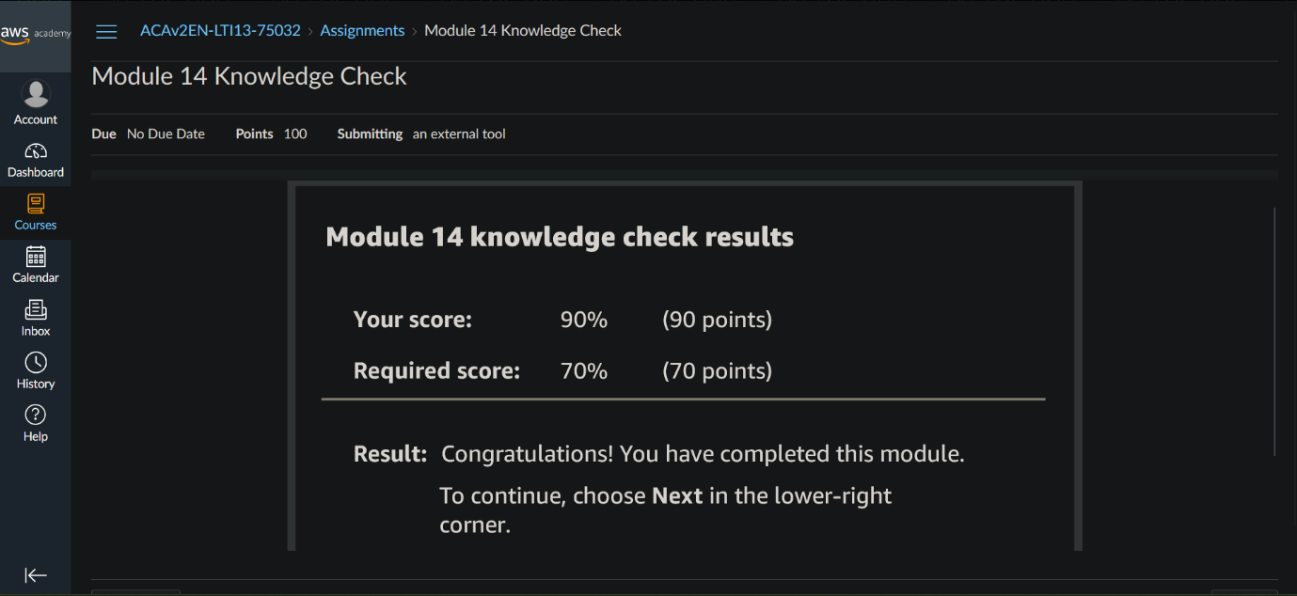

Module 14 Guided Lab - Hybrid Storage and Data Migration with AWS Storage Gateway File Gateway

Task 1: Reviewing the lab architecture

In this lab, I configured a system to migrate data from an on-premises server to a secure Amazon S3 bucket. First, I defined the regions where different components would reside and created two S3 buckets in separate regions to act as data repositories. I then enabled versioning on both buckets to ensure I could track any changes to the data.

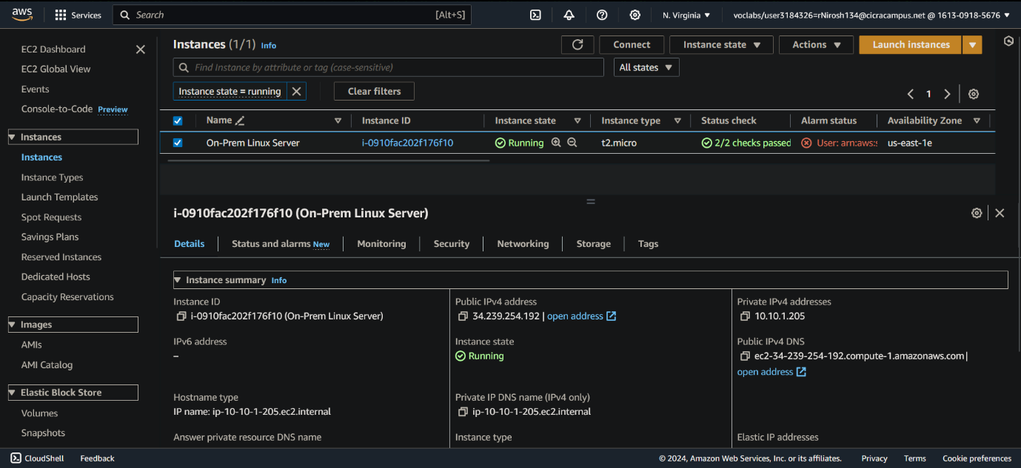

Task 2: Creating the primary and secondary S3 buckets

Next, I created the buckets themselves within S3, essentially building the storage locations for the data.

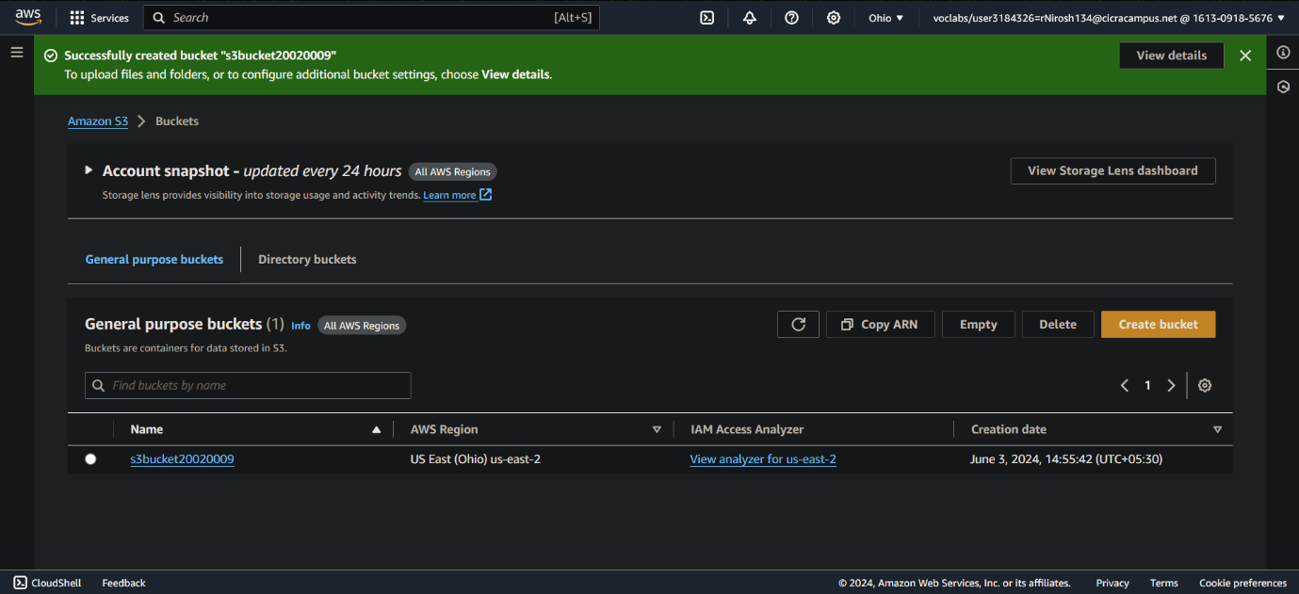

Here again, I remembered to enable versioning for both buckets to maintain a history of file revisions.

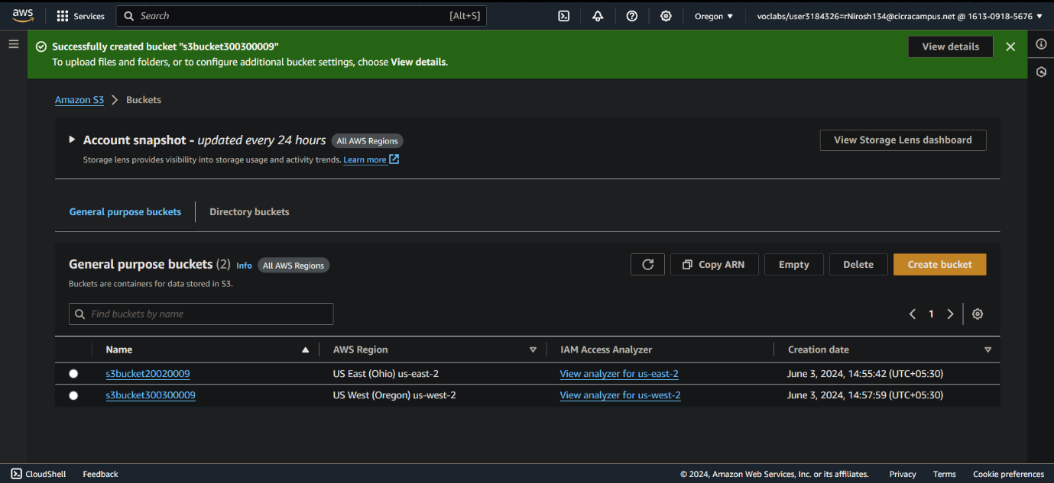

Task 3: Enabling cross-Region replication

To safeguard the data, I established an automatic replication system between the buckets. I configured a rule that instructed the system to copy all data from the source bucket to the destination bucket.

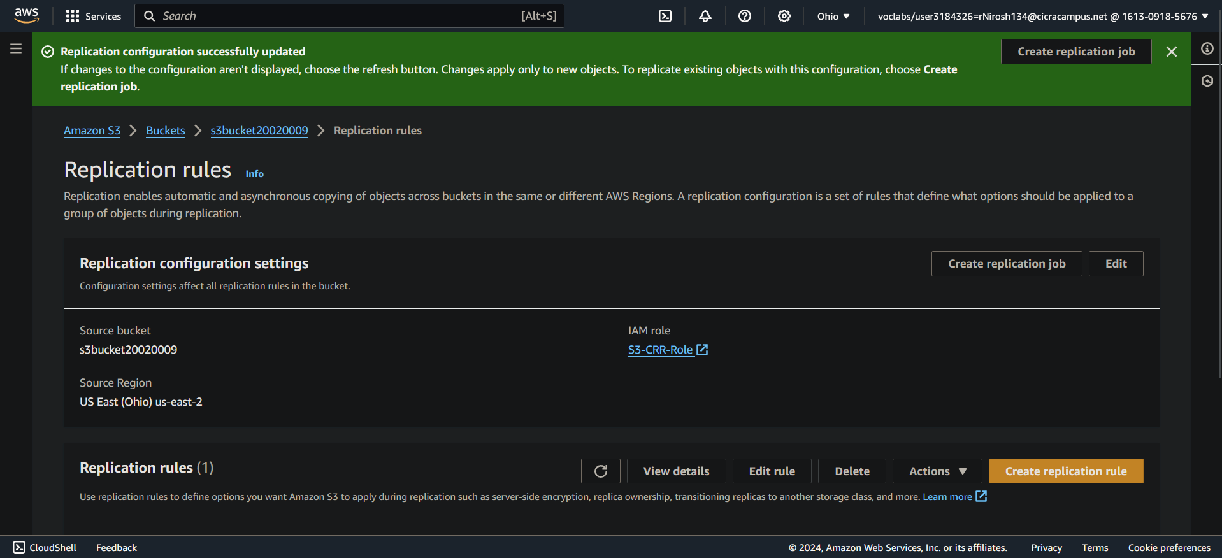

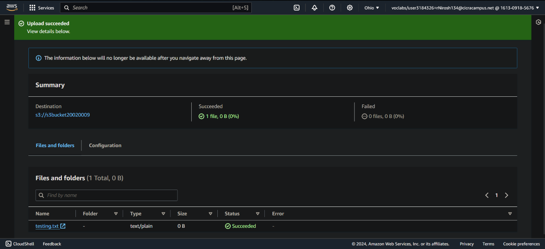

To verify this process, I uploaded a test file to the source bucket and confirmed its successful replication to the destination bucket.

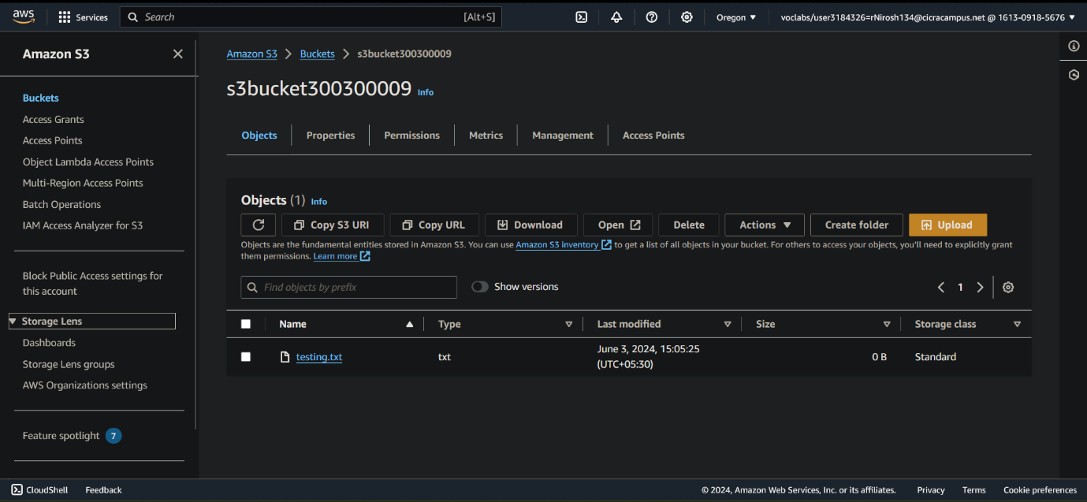

Task 4: Configuring the File Gateway and creating an NFS file share

The following step involved setting up a File Gateway, essentially a virtual machine on Amazon. This gateway acted as an intermediary, connecting to my S3 bucket and managing the data transfer process.

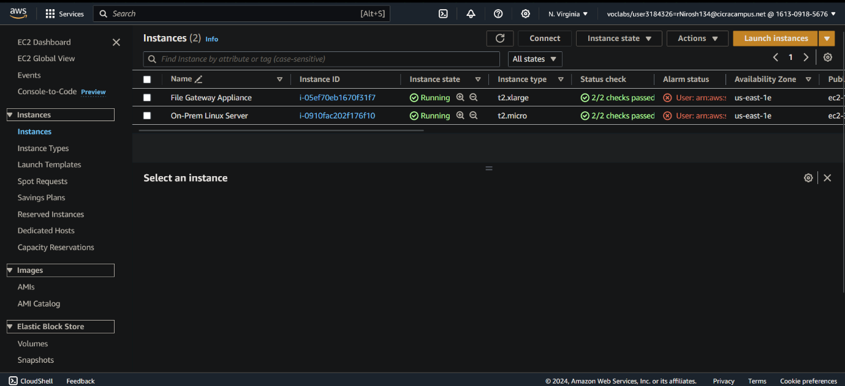

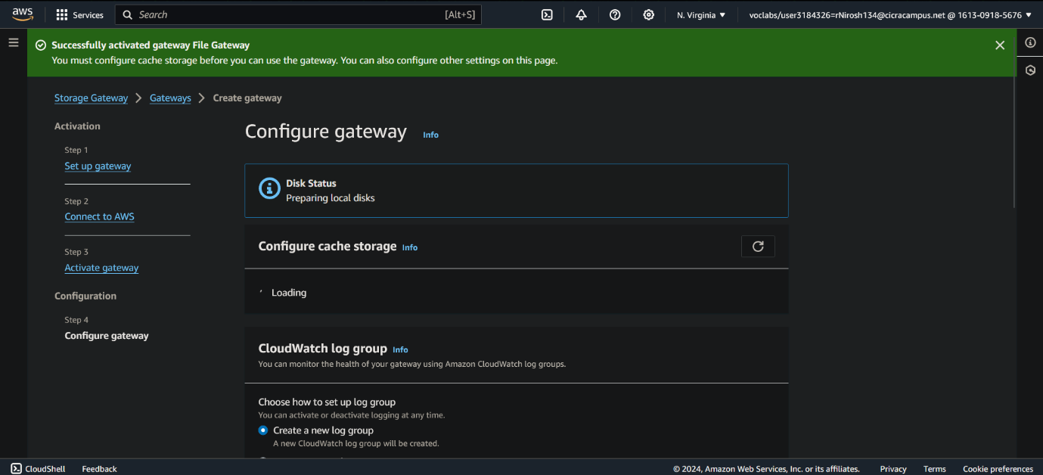

I also configured a file share on the gateway, creating a designated folder specifically for the data transfer.

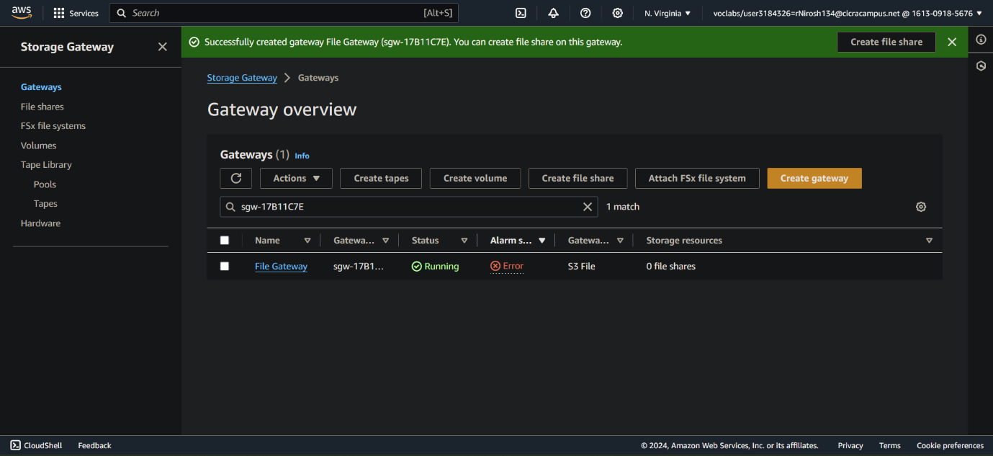

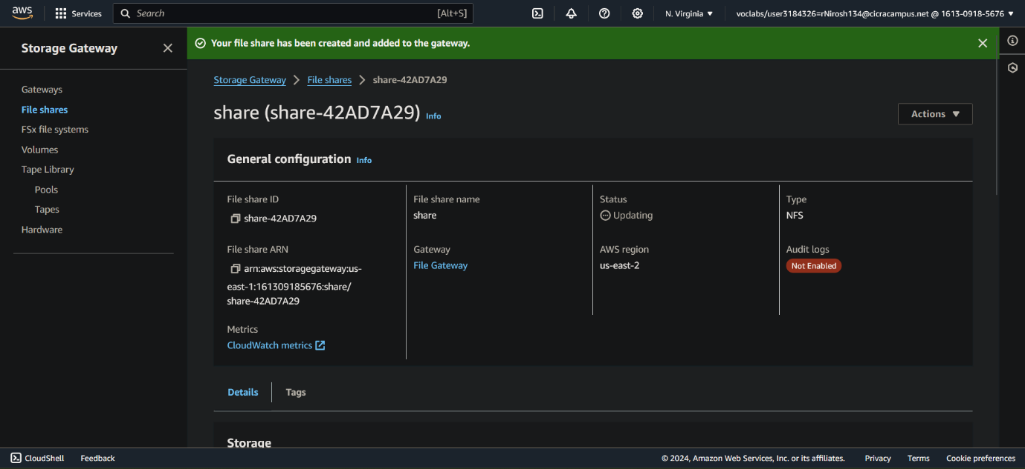

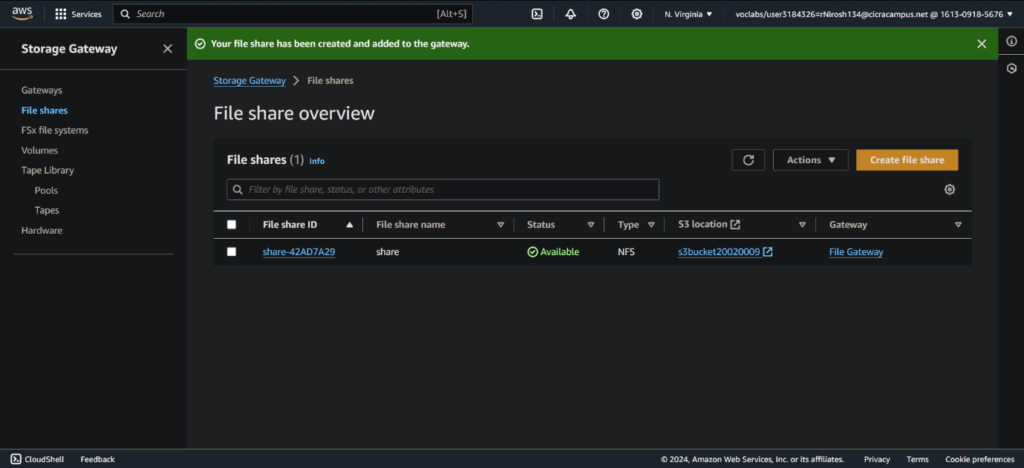

Task 5: Mounting the file share to the Linux instance and migrating the data

Using SSH, I logged into my on-premises server, the physical location of the data I intended to migrate. On the server, I created a new folder to hold the transferred data. Then, I connected the file share from the File Gateway to the server, akin to plugging in a USB drive.

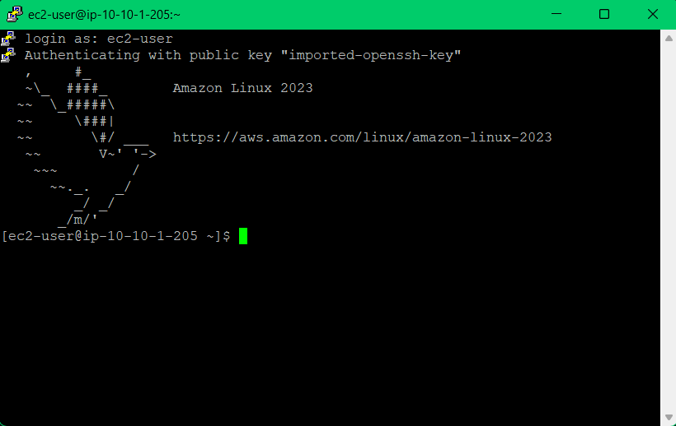

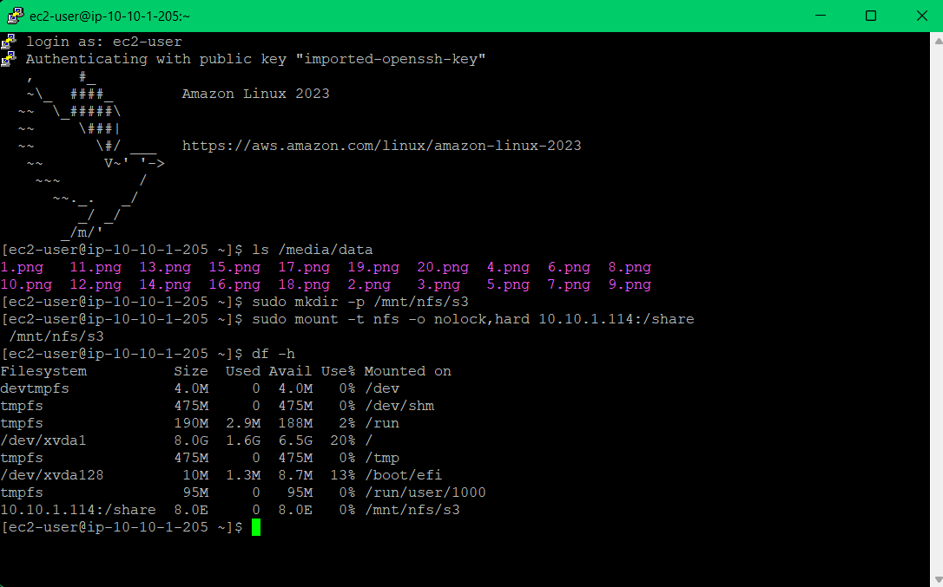

Finally, I copied all the data from the server to the file share, preparing it for upload to S3.

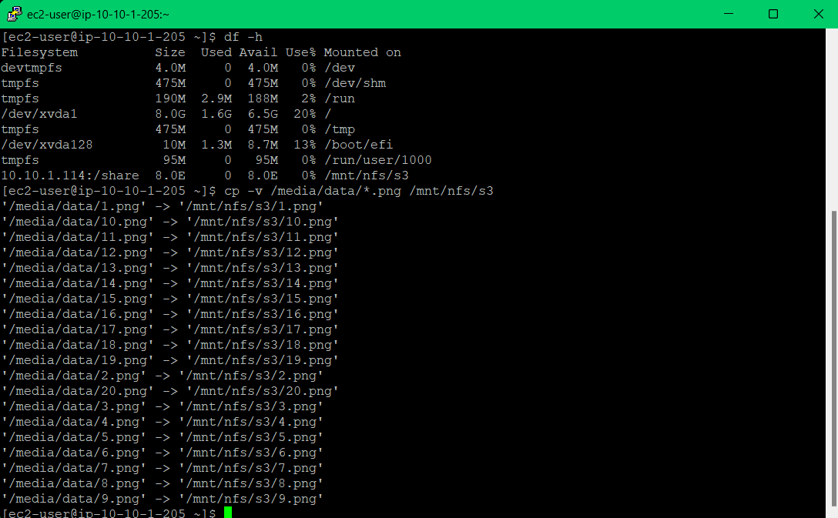

Task 6: Verifying that the data is migrated

The final step involved verifying the successful data migration. I first checked the original S3 bucket to confirm all the data had been uploaded. Then, I went to the second bucket and, thanks to the previously configured replication rule, all the data had been copied there as well.
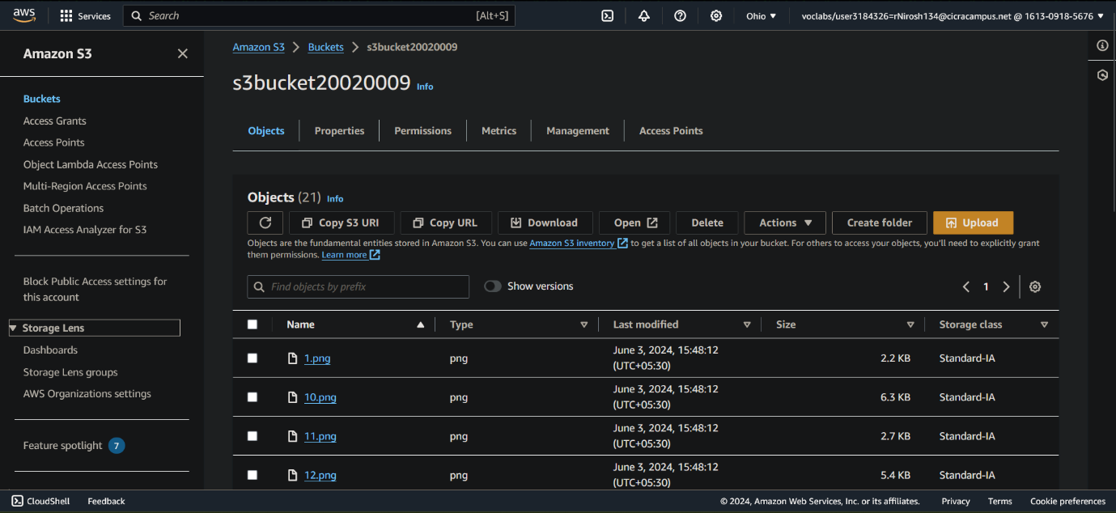

This confirmed the success of the migration, ensuring my data was now securely stored in the cloud, with an additional backup in a separate location.



Grade:

My grade is 40/40

